**Viewer Drop-Off Rate Analysis - Entertainment Sector**

Pooja Joshi & E.Code [E25007]

# Overview :

# The purpose of this task was to perform a Viewer Drop-Off Rate Analysis for the entertainment sector. We aimed to analyze how the number of viewers declines over time or with respect to different factors such as popularity, vote average, and valuation. This report covers the steps taken to explore the data, calculate drop-off rates, and generate visualizations.

# Objective:

· Analyze the viewer drop-off rate to understand how viewership decreases over time or with respect to factors like popularity.

· Explore how attendance_count varies with different factors such as vote_average and valuation.

· Provide visual representations of these relationships to aid understanding of viewer behavior in the entertainment sector.

# Assigned Task(s) :

1. **Data Inspection**: Load and inspect the CSV file to identify relevant fields for analysis.
2. **Viewer Drop-Off Rate Calculation**: Calculate the drop-off rate using attendance data and plot the results.
3. **Attendance vs Other Variables**: Analyze how attendance changes in relation to variables like **vote_average** and **valuation**.
4. **Plot and Visualize**: Generate clear visualizations to represent the results of the analysis.

# Task Details :

**Task 1: Data Loading and Inspection**

* + **Status**: Completed
  + **Details**: Loaded the dataset and inspected the column names, identifying relevant fields like **attendance_count**, **popularity**, **vote_average**, and **valuation**.

**Task 2: Viewer Drop-Off Rate Calculation**

* + **Status**: Completed
  + **Details**: Calculated the drop-off rate by computing the percentage change in **attendance_count** across time or using **popularity** as a proxy for time.

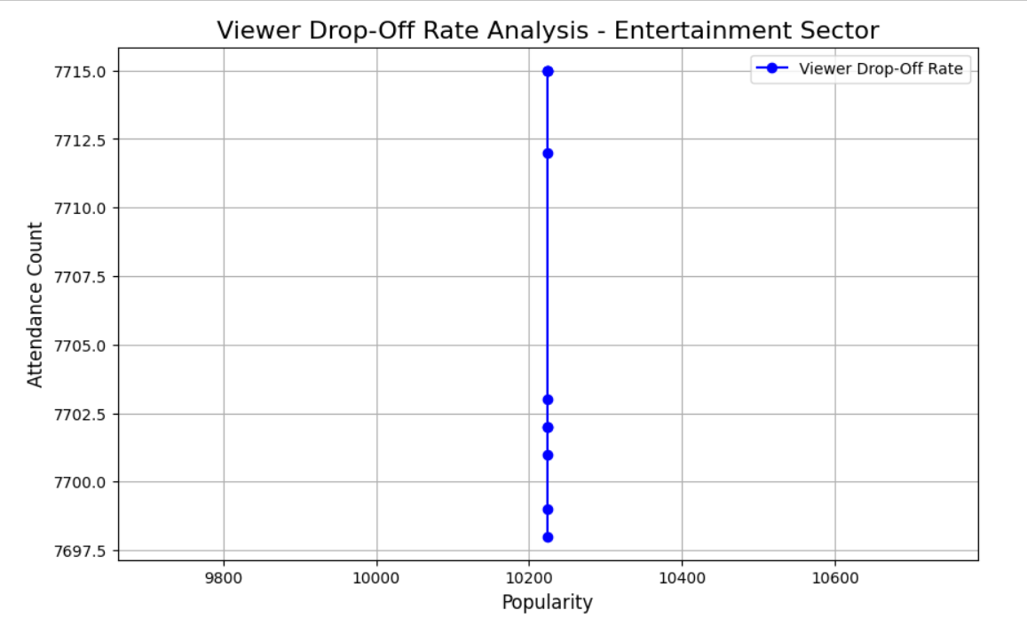

**Task 3: Attendance vs Vote Average and Valuation**

* + **Status**: Completed
  + **Details**: Analyzed how **attendance_count** changes with **vote_average** and **valuation** using scatter plots.

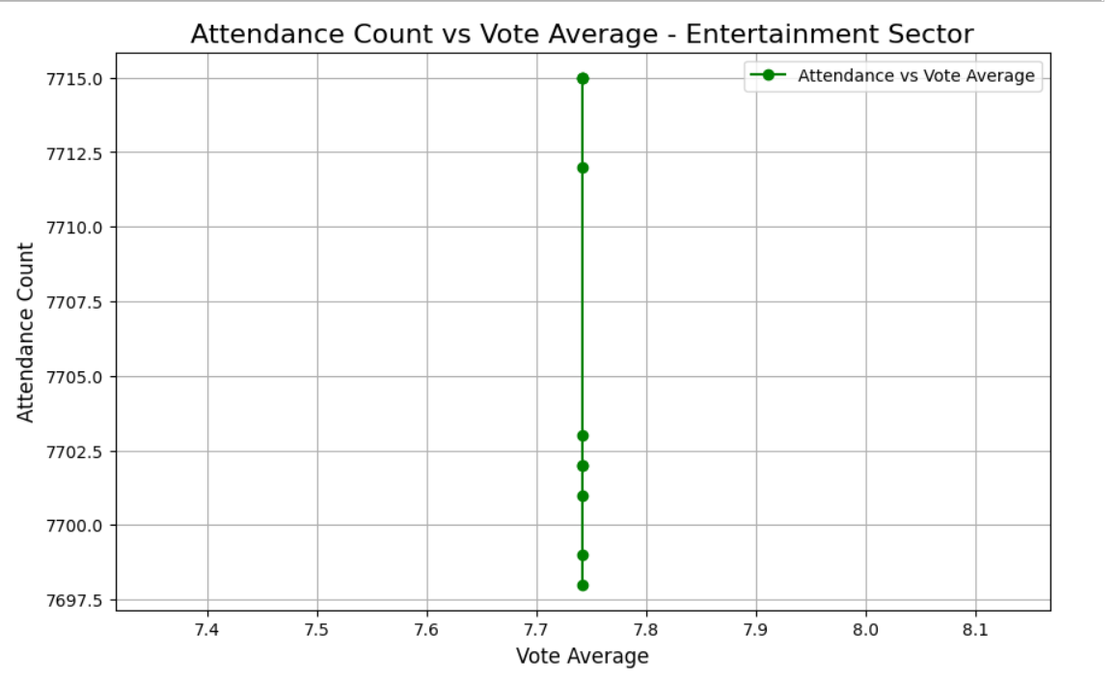

**Task 4: Visualizations**

* + **Status**: Completed
  + **Details**: Created plots to show the relationship between **attendance_count** and both **vote_average** and **valuation**.

# 

# 

**Progress :**

· **Accomplishments**:

* Successfully loaded and inspected the dataset.
* Generated plots showing viewer drop-off rates, as well as how attendance correlates with vote average and valuation.

· **Metrics**:

* Drop-off rate based on **attendance_count**.
* Attendance variation with respect to **vote_average** and **valuation**.

# Challenges and Solutions :

#### ****Challenges Faced:****

· **Challenges Faced**:

Initial difficulty identifying the correct columns for the analysis (e.g., determining whether **popularity** could serve as a time proxy for drop-off rates).

· **Solutions Implemented**:

Inspected the dataset to find appropriate fields and recalculated the drop-off rate using **popularity** and **attendance_count** as key metrics.

# Next Steps :

· **Upcoming Tasks**:

* Further refine the drop-off analysis by finding better time-based data or deriving time proxies.
* Investigate other factors (e.g., **sentiment** or **valuation**) to expand the analysis.

· **Goals**:

* Complete the drop-off rate analysis with a more refined understanding of time or engagement measures.

# \

# Conclusion :

# Summary: The Viewer Drop-Off Rate Analysis involved calculating and visualizing how viewer engagement declines over time or with respect to other variables. We successfully explored how attendance changes in relation to vote average and valuation, providing insights into viewer behavior patterns in the entertainment sector.

# **Acknowledgments**: Thank the audience for their time and attention.

# Instructions:

1. Use Google Docs. Single Column
2. TNR stands for Times New Roman: B - Bold
3. Use images as required with proper references
4. Use charts, tables as per your requirement.
5. Number of Pages: 2 to 8 for each task report.